|  |  |  |  |  |  |  |
| --- | --- | --- | --- | --- | --- | --- |
| **Student name:** | **Hussaina Hussain** | | | | | |
| **Student number:** | **3136381** | | | | | |
| **Faculty:** | **Computing Science** | | | | | |
| **Course:** | **BSCH/BSCO/EXCH** | | | **Stage/year:** | **2** | |
| **Subject:** | **Software Development 2** | | | | | |
| **Study Mode:** | Full time |  |  | Part-time |  |  |
| **Lecturer Name:** | **Gemma Deery** | | | | | |
| **Assignment Title:** | **Worksheet 1** | | | | | |
| Date due: | **19/02/2025** | | |  | | |
| Date submitted: | **19/02/2025** | | |  | | |
| **Plagiarism disclaimer:**  *I understand that plagiarism is a serious offence and have read and understood the college policy on plagiarism. I also understand that I may receive a mark of zero if I have not identified and properly attributed sources which have been used, referred to, or have in any way influenced the preparation of this assignment, or if I have knowingly allowed others to plagiarise my work in this way.*  *I hereby certify that this assignment is my own work, based on my personal study and/or research, and that I have acknowledged all material and sources used in its preparation. I also certify that the assignment has not previously been submitted for assessment and that I have not copied in part or whole or otherwise plagiarised the work of anyone else, including other students.*  **Signed: Hussaina Hussain Date: 19/02/2025** | | | | | | |
| Please note: Students MUST retain a hard / soft copy of ALL assignments as well as a receipt issued and signed by a member of Faculty as proof of submission. | | | | | | |

## Task One

### **Part One:**

* Created the class Grades.java under the package griffith and GradesTest.java under the package griffithTest.

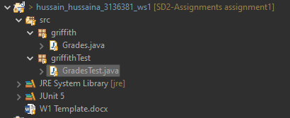

* Stub methods added in Grades.java

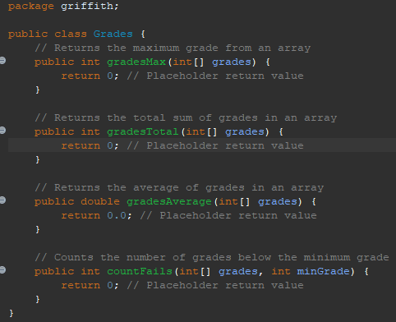

* Stub methods added in GradesTest.java

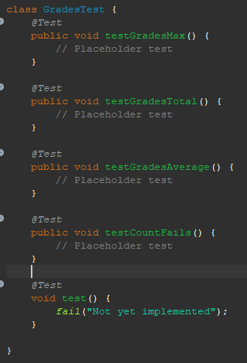

### **Part Two:**

* Writing test cases for each of the unit test methods that call the appropriate methods in java file.

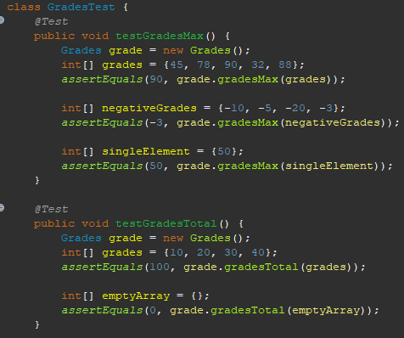

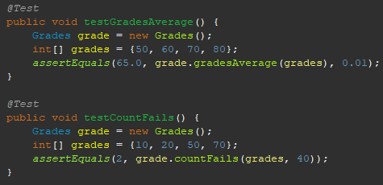

* Failing tests:  
  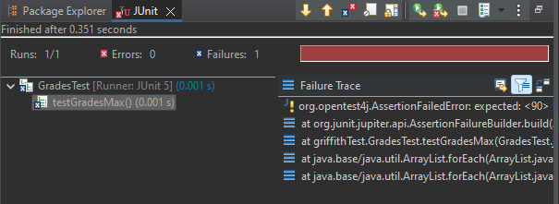

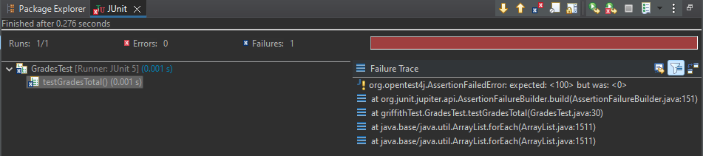

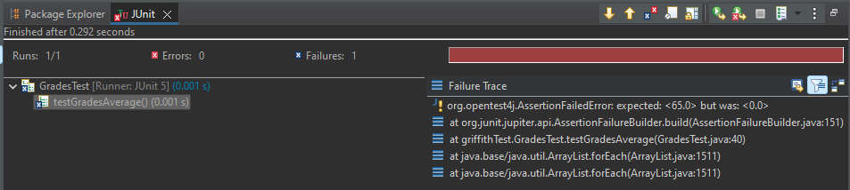

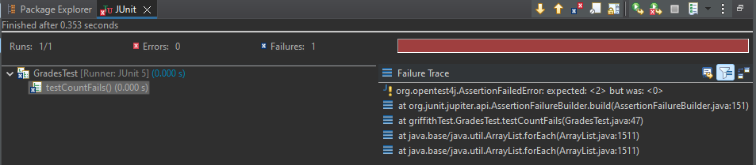

### **Part Three:**

* Implementing and testing gradesMax method and testing it.

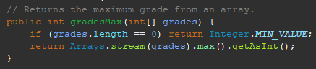

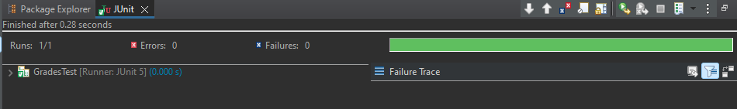

* Implementing and testing gradesTotal method and testing it.

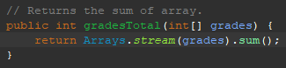

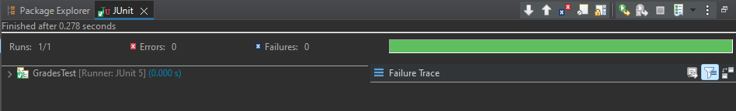

* Implementing and testing gradesAverage method and testing it.

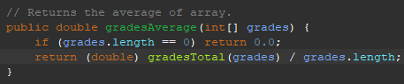

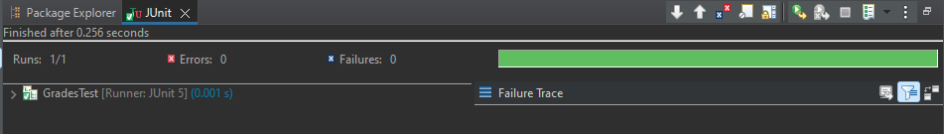

* Implementing and testing countFails method and testing it.

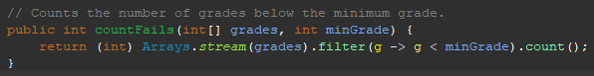

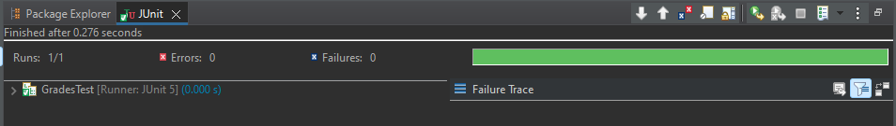

## Task 2

### **Part One:**

* Created the class Word.java under the package griffith and WordTest.java under the package griffithTest.

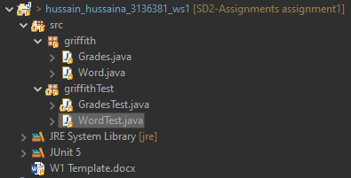

* Updated the Word.java file with the stub methods.

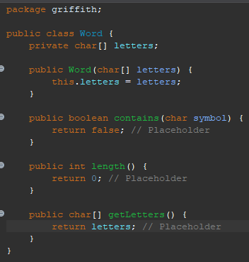

* Updated the WordTest.java file with the stub methods.

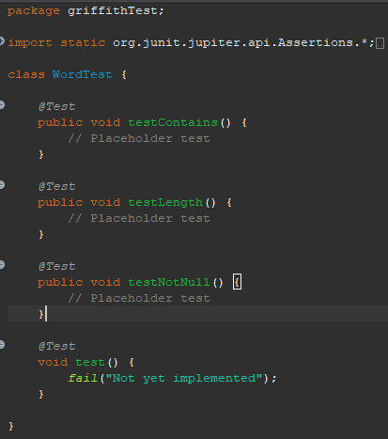

## Part Two: